Katy Granath

LIS 545

Mayernik

03.14.2023

**Repository Profile**

*Repository Overview: Open Science Framework (OSF)*

I chose this repository because it is a free, multi-disciplinary repository that takes open data submissions, and because a preliminary search revealed that it already holds other datasets related to fanfiction, transformative works, and AO3. Additionally, the goals and values of OSF align with my own, and furthermore OSF offers free open-source project management tools, which I would be likely to utilize were I depositing data for a project. Please see the attached diagram detailing OSF’s “Self-Assessment of NIH Desirable Characteristics for Selecting a Data Repository.”

* OSF Homepage: <https://osf.io/>
* OSF Support: Create a Project ([Link](https://help.osf.io/article/252-create-a-project))
* OSF Wiki: Metadata ([Link](https://osf.io/j6ayt/wiki/Metadata/))
* OSF Privacy Policy ([Link](https://github.com/CenterForOpenScience/cos.io/blob/master/PRIVACY_POLICY.md))
* OSF Terms & Conditions ([Link](https://github.com/CenterForOpenScience/cos.io/blob/master/TERMS_OF_USE.md))
* OSF according to RE3: <https://www.re3data.org/search?query=OSF>
* Center for Open Science: “How OSF Meets ‘Desirable Characteristics for Data Repositories’ (2022, July 13) Pfeiffer, N. & Call, M. ([Link](https://www.cos.io/blog/how-osf-meets-desirable-characteristics-for-data-repositories))

*Overview of Data Depositing:*

The Open Science Framework is a free, multi-disciplinary repository that accepts data submissions from anyone. Data does not need to be science related. No assistance or consulting is available to depositors, although OSF maintains clear and accessible digital guides. To deposit data, a user must make an account, which is painlessly quick and easy. There are no restrictions on who is allowed to make an account. When depositing data, a user will be asked to input basic information like title and contributor. Users who make their data publicly available are issued a free DOI.

Adding additional information like tags, funders, related topics or disciplines, or other metadata is optional. There is no mandatory standard that OSF applies to user-generated metadata. Instead, OSF recommends that depositors use metadata standards associated with their field or data. They suggest utilizing the Digital Curation Centre’s directory of metadata standards, or generic metadata schema like Dublin Core or the Datasite Metadata Schema.

There are some limits to the size of data files that can be accepted. Individual files cannot exceed 5 GB, although there are exceptions by uploading data as an add-on. There is no limit on the amount of data that a single user can deposit over time, although there are limits to the size that projects can be (although again it does seem there are exceptions to the rule by using the add-on feature). There are no limitations of the data type, domain, or file format that are accepted by OSF.

*Overview of Data Access*

No login, registration, or payment is required to access or download data that is publicly available. If a depositor has not made data publicly available, then it is accessible only to that depositor. It is unclear to me whether more than one access mechanism is provided or how to determine the available access mechanisms other than direct file download. Some data like papers (preprint or published) and spreadsheets can be viewed online in a browser in addition to being downloadable files.

*OSF Self-Assessment of NIH's desirable characteristics for selecting a data repository*

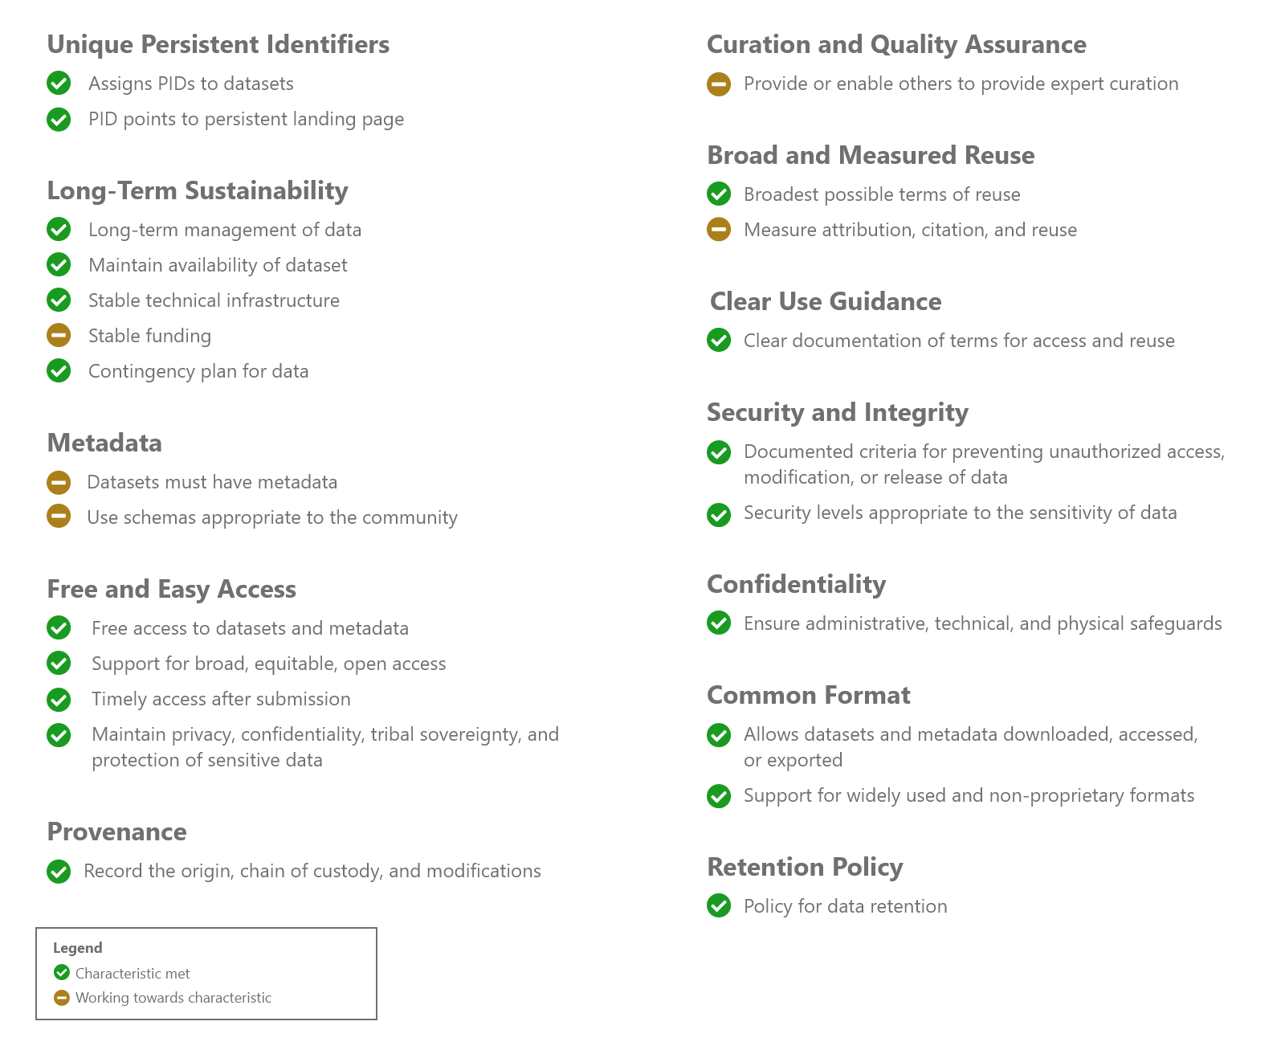

Center for Open Science: “How OSF Meets ‘Desirable Characteristics for Data Repositories’ (2022, July 13) Pfeiffer, N. & Call, M. ([Link](https://www.cos.io/blog/how-osf-meets-desirable-characteristics-for-data-repositories))